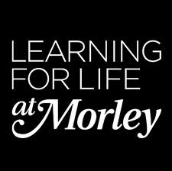
Educate Out Prejudice Curriculum Pilot
Introduction to Childcare with English - Catherine O’Shea
Contents:
- Lesson Plan (pp. 2 – 4)
- Group Profile with Equality and Diversity Statement (pp. 5)
- Resources (pp. 6 – 15)

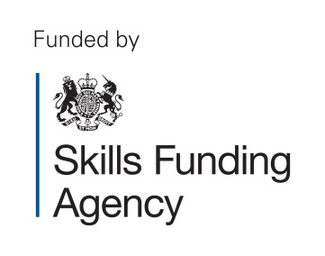
The creation of this material by Morley College has been financed by the Skills Funding Agency Equality and Diversity Innovation Fund 2013/14.Copyright in this material is vested in the Crown but it is made freely available through an Open Government Licence. This licence enables you to use and adapt the material but you must attribute Morley College as the creator and include details of the licence. Full details of the licence are available at http://www.nationalarchives.gov.uk/doc/open-government-licence/

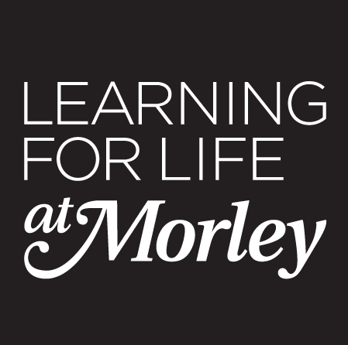 LESSON PLAN Essential Skills 2013-2014

COURSE TITLE: Introduction to Childcare with English  COURSE CODE: FEE007A/FEE008A |  | TUTOR  Catherine O’Shea | WEEK NO  7 | DATE OF LESSON  8/3 | NO. OF LEARNERS  5
LEARNING OUTCOMES  (What the student will know or be able to demonstrate by the end of the session) | By the end of the session students will be able to:  1. Discuss LGBT parenting  2. Design and make a children’s book as a nursery activity  3. Answer comprehension questions on ‘A letter to Skyla’

TIME | PURPOSE  (stage of lesson and learning outcome it links to) | LEARNER AND TEACHER ACTIVITY | DIFFERENTIATION/DIVERSITY* | ASSESSMENT OF LEARNING  (How will student’s progress in the lesson be assessed?) | RESOURCES
10 | 1 | Class discussion: Teacher asks the class key questions: What is a family? Who is in your family? Who might be bringing children to a nursery you are working in? | Equalities discussion about different parents– ethnicity, culture, religion, sexual orientation.
10 | 1 | UN (United Nations) Convention of Children’s Rights  Teacher asks students to write a definition: What does equality and diversity mean?  With a partner list different people who might be parents. | LGBT adoption, parenting. | Share list with the group. | Article on the UN Convention.
15 | 1/2 | Book making activity. Teacher asks students to plan a book for nursery children about different types of families. |  |  | Initial planning sheet.
15 | 1/2 | Rough draft: Add photos and images to your book.  Share with the class, feedback from the group. | Give images and story template to lower ability students | Review planning sheet | Photos of families and parents.
10 | 2 | Book binding activity. Teacher demonstrates different ways to make a paper book. |  |  | Paper and scissors.
15 | 2 | Make final version of story about different families. |  |  | Paper, scissors, glue, images.
15 | 1/3 | Read ‘A letter to my daughter Skyla’  Group discussion – teacher asks comprehension questions.
20 | 3 | Use as a OCR Level 1 English Reading Exam Practice
10 | 1 | Speaking and Listening: Preparation for an exchange – Prepare to speak with LGBT parents about what their 3 year old daughter calls them. ‘Mum and Mummy’ ‘Dad and Daddy’ etc. | Preparing to work in a nursery with LGBT parents. | Prepare for Speaking and Listening exchange the following week. | A letter to Skyla  An exchange planning sheet.

*How will your lesson take account of different learning needs, learning styles and abilities/levels? How will it support and promote E and D? For example: Gender, Race, Disability, Cultural and ethnic b/ground, sexual orientation?
EVALUATION OF LESSON (Were the learning outcomes achieved? What was successful? What could be improved? Is there anything that needs to be carried over to the next session?)

This work was part of our Unit 4 Childcare – this component focusses on Equality and Diversity. We had been studying the UN Convention on the rights of the Child for three weeks previously.

In the previous lesson as part of LGBT history month I took the class to a talk by a student from Kyrgzstan who is an LGBT activist and had been persecuted. The students found the talk inspiring and liked the talk and the way the speaker delivered it. The women I teach were giggling at the idea of the homosexuality and I had to challenge some of their ideas. They agreed that even if they are not comfortable with the idea of homosexuality that no one should ever be treated how this student was. One student said that although she is not comfortable with people being homosexual in public she does believe that everyone should be treated equally.

I wanted to present this letter in the same way as any regular text we might use in class. I did not start with a specific focus on LGBT issues and I found it useful to simply embed a text with equalities awareness in this way.

Using this lesson plan worked well. For the childcare context using the UN Convention and relating it to LGBT issues was very effective. The idea that there future students may have LGBT parents was also positive and useful to explore.

HOMEWORK

Prepare for Speaking and Listening exchange next week. Use these ideas and prepare to deliver the following week – NB these exchanges were very positive.

Speaking and Listening: Preparation for an exchange – Prepare to speak with LGBT parents about what their 3 year old daughter calls them. ‘Mum and Mummy’ ‘Dad and Daddy’ etc.

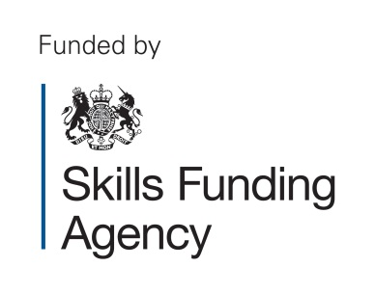
The creation of this material by Morley College has been financed by the Skills Funding Agency Equality and Diversity Innovation Fund 2013/14.Copyright in this material
is vested in the Crown but it is made freely available through an Open Government Licence. This licence enables you to use and adapt the material but you must attribute
Morley College as the creator and include details of the licence. Full details of the licence are available at http://www.nationalarchives.gov.uk/doc/open-government-licence/

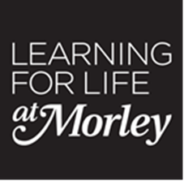 Essential Skills 2013-2014

Group Profile with Equality and Diversity Statement

Course Title: Introduction to Childcare with English

Course Code: | FEE007A | Level | L1
Number on register | 5 | Tutor: C O'Shea
Comments on the group (issues which impact on the way you organise the group or plan your teaching, e.g. size, range of ability, mixture of beginners/experienced, any learning support needs or disabilities, range of ages, learning styles of students etc)

In this group there are 5 students with a variety of needs. The students’ first languages are Arabic, Spanish, French and Somali. All the students are women with young families and experience of childcare. They are mostly wanting to apply for jobs as teaching assistants. One of the five students is very able and will confidently achieve the level 1 functional skills, it will be more of a challenge for the other 4.

Differentiation for this group based on the above

For this group it is necessary to constantly change pairings so that the range of abilities all work with different students. It is also necessary to have an extension or stretch activity for every task for the more able and also a simplified version. For the four students working at a lower level it is necessary for me to monitor their progress at every stage to make sure they are following the work.
Equality and Diversity and Safeguarding

I confirm that I will treat all students equally in this class and make sure that all students treat each other with respect. I will pay full attention to the welfare of my students and report any concerns to my line manager and the college.

Embedding LGBT – Introduction to Childcare Level 1: Resources.

- Resource: Children’s human rights (pp.7)
Online Source: GOV UK (2014) The United Nations Convention on the Rights of the Child (UNCRC), [Online], Available: https://www.gov.uk/government/policies/creating-a-fairer-and-more-equal-society/supporting-pages/the-united-nations-convention-on-the-rights-of-the-child-uncrc [ 20 June 2014].
- Resource: UN Convention on the Rights of the Children Child Friendly Language (pp.8-12)
- Resource and Worksheet ‘Dear Skyla Letter’ (pp.13-15)

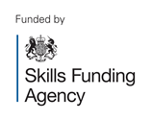
The creation of this material by Morley College has been financed by the Skills Funding Agency Equality and Diversity Innovation Fund 2013/14.Copyright in this material is vested in the Crown but it is made freely available through an Open Government Licence. This licence enables you to use and adapt the material but you must attribute Morley College as the creator and include details of the licence. Full details of the licence are available at http://www.nationalarchives.gov.uk/doc/open-government-licence/

The creation of this material by Morley College has been financed by the Skills Funding Agency Equality and Diversity Innovation Fund 2013/14.Copyright in this material is vested in the Crown but it is made freely available through an Open Government Licence. This licence enables you to use and adapt the material but you must attribute Morley College as the creator and include details of the licence. Full details of the licence are available at http://www.nationalarchives.gov.uk/doc/open-government-licence/

Children's human rights www.directgov.uk/parents
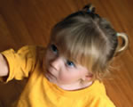
The United Nation's Convention on the Rights of the Child (UNCRC) applies to all children and young people aged 17 and under. The Convention is separated into 54 'articles': most give children social, economic, cultural or civil and political rights; while others set out how governments must publicise or implement the Convention.

What is the UNCRC?
All children and young people up to the age of 18 years have all the rights in the Convention. Some groups of children and young people - for example those living away from home, and young disabled people - have additional rights to make sure they are treated fairly and their needs are met.
The UK ratified the Convention on the Rights of the Child (UNCRC) on 16 December 1991. That means the UK government now has to make sure that every child has all the rights outlined in the treaty except in those areas where the government has entered a specific reservation.
A convention is an agreement between countries to obey the same law. When the government of a country ratifies a convention, that means it agrees to obey the rules set out in that convention.

What the treaty means
From 15 January 1992, when the treaty came into force, every child in the UK has been entitled to over 40 specific rights. These include:
- the right to life, survival and development
- the right to have their views respected, and to have their best interests considered at all times
- the right to a name and nationality, freedom of expression, and access to information concerning them
- the right to live in a family environment or alternative care, and to have contact with both parents wherever possible
- health and welfare rights, including rights for disabled children, the right to health and health care, and social security
- the right to education, leisure, culture and the arts
- special protection for refugee children, children in the juvenile justice system, children deprived of their liberty and children suffering economic, sexual or other forms of exploitation
The rights included in the convention apply to all children and young people, with no exceptions.

UN Convention
on the Rights of the Child
In Child Friendly
Language
“Rights" are things every child should have or be able to
do. All children have the same rights. These rights are listed
in the UN Convention on the Rights of the Child.
Almost every country has agreed to these rights. All the
rights are connected to each other, and all are equally
important. Sometimes, we have to think about rights in
terms of what is the best for children in a situation, and
what is critical to life and protection from harm. As you
grow, you have more responsibility to make choices and
exercise your rights.

Article 1
Everyone under 18 has these rights.
Article 2
All children have these rights, no matter who
they are, where they live, what their parents do,
what language they speak, what their religion is,
whether they are a boy or girl, what their culture
is, whether they have a disability, whether they
are rich or poor. No child should be treated
unfairly on any basis.
Article 3
All adults should do what is best for you. When
adults make decisions, they should think about
how their decisions will affect children.
Article 4
The government has a responsibility to make sure
your rights are protected. They must help your
family to protect your rights and create an environment
where you can grow and reach your
potential.
Article 5
Your family has the responsibility to help you
learn to exercise your rights, and to ensure that
your rights are protected.
Article 6
You have the right to be alive.
Article 7
You have the right to a name, and this should be
officially recognized by the government. You have
the right to a nationality (to belong to a country).
Article 8
You have the right to an identity – an official
record of who you are. No one should take this
away from you.
Article 9
You have the right to live with your parent(s),
unless it is bad for you. You have the right to live
with a family who cares for you.
Article 10
If you live in a different country than your parents
do, you have the right to be together in the
same place.
Article 11
You have the right to be protected from kidnapping.
Article 12
You have the right to give your opinion, and for
adults to listen and take it seriously.
Article 13
You have the right to find out things and share
what you think with others, by talking, drawing,
writing or in any other way unless it harms or
offends other people.
Article 14
You have the right to choose your own religion
and beliefs. Your parents should help you decide
what is right and wrong, and what is best for
you.
Article 15
You have the right to choose your own friends
and join or set up groups, as long as it isn't
harmful to others.
Article 16
You have the right to privacy.
Article 17
You have the right to get information that is
important to your well-being, from radio, newspaper,
books, computers and other sources.
Adults should make sure that the information
you are getting is not harmful, and help you
find and understand the information you need.
Article 18
You have the right to be raised by your parent(
s) if possible.
Article 19
You have the right to be protected from being
hurt and mistreated, in body or mind.
Article 20
You have the right to special care and help if
you cannot live with your parents.
Article 21
You have the right to care and protection if
you are adopted or in foster care.
Article 22
You have the right to special protection and
help if you are a refugee (if you have been
forced to leave your home and live in another
country), as well as all the rights in this
Convention.
Article 23
You have the right to special education and
care if you have a disability, as well as all the
rights in this Convention, so that you can live a
full life.
Article 24
You have the right to the best health care possible,
safe water to drink, nutritious food, a
clean and safe environment, and information
to help you stay well.
Article 25
If you live in care or in other situations away
from home, you have the right to have these
living arrangements looked at regularly to see
if they are the most appropriate.
Article 26
You have the right to help from the government
if you are poor or in need.
Article 27
You have the right to food, clothing, a safe
place to live and to have your basic needs met.
You should not be disadvantaged so that you
can't do many of the things other kids can do.
Article 28
You have the right to a good quality education.
You should be encouraged to go to school to
the highest level you can.
Article 29
Your education should help you use and develop
your talents and abilities. It should also help
you learn to live peacefully, protect the environment
and respect other people.
Article 30
You have the right to practice your own culture,
language and religion - or any you choose.
Minority and indigenous groups need special
protection of this right.
Article 31
You have the right to play and rest.
Article 32
You have the right to protection from work that
harms you, and is bad for your health and education.
If you work, you have the right to be
safe and paid fairly.
Article 33
You have the right to protection from harmful
drugs and from the drug trade.
Article 34
You have the right to
be free from sexual
abuse.Article 35No one is
allowed to kidnap or sell
you.
Article 36
You have the right to protection
from any kind of exploitation (being
taken advantage of).
Article 37
No one is allowed to punish
you in a cruel or harmful way.
Article 38
You have the right to protection
and freedom from war. Children
under 15 cannot be forced to go into
the army or take part in war.
Article 39
You have the right to help if you've been hurt,
neglected or badly treated.
Article 40
You have the right to legal help and fair treatment
in the justice system that respects your
rights.
Article 41
If the laws of your country provide better protection
of your rights than the articles in this
Convention, those laws should apply.
Article 42
You have the right to know your rights!
Adults should know about these rights and
help you learn about them, too.
Articles 43 to 54
These articles explain how governments and
international organizations like UNICEF will
work to ensure children are protected with
their rights.

To: hannahbrown@postmail.com
From: letterstoskyla@postmail.com
Subject: First Day! Date: 21/3/2014
Dear Skyla,
Today was your first day at nursery. It was a very important day for me and your mum Gill. You are only three years old. When you are older I will show you these emails. I have sent you an email on every day of your life. They will be a record of our family life together.
The nursery we chose for you is in Kennington in South London. It is near the flat that we live in with your second mum Gill. The nursery is called Bright Smiles nursery, we chose it because the staff were very friendly when we visited. I hope you will like it there. You have always been very confident playing with other children and speaking to adults.
I felt very emotional when I went to drop you off at the nursery. Of course I have left you with other people before but this is the beginning of a new chapter in our lives. Every morning I will leave you to play with the other children at the Bright Smiles nursery.
This morning you were very brave. You walked confidently in. You listened to the nursery teacher’s instructions about where to hang up your coat and bag. You did not cry – perhaps you were too excited about all the toys and other children to play with. What did you think of the nursery?
When I was a young woman I thought I would never be able to have children. I thought I would not be able to have my own family because I am gay. The day you were born was the most special day of my life. I feel so lucky to be your mother.
I am worried about what could happen when you talk to other people about your two mothers. There is less discrimination now but you will still come across prejudice at some point. I hope you don’t overhear your teacher or another parents talking about the fact that you have two lesbian mothers.
I hope that you don’t get teased by other children. I hope you won’t resent us because of other peoples’ prejudices. – Sorry I am jumping ahead of myself and I am being paranoid.
Today was your first day at nursery. We are so proud of you. I can’t wait to pick you up at 3pm and hear all about your first day.
Lots of love
Your mummy Hannah,

- What type of text is this?

- How can you tell?

- Who is the sender?

- Who is the recipient?

- What is the subject and purpose of this email?

- What is the tone and style of the email?

- What is the relationship between Skyla and Hannah?

- Who is Gill?

- Where do they live?

- What is the name of the nursery?

- Why did Hannah think she would not have a family?

- What is Hannah worried about?

- When will Hannah pick Skyla up?

- What do you think Hannah means when she writes ‘other people’s prejudices?’

